APPLICATION FORM FOR BEYOND TIME/POZA CZASEM ARTIST-IN-RESIDENCE PROGRAM

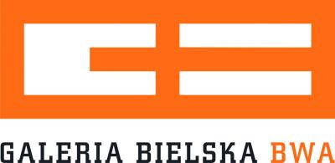
Bielska Gallery BWA
ul. 3 Maja 11
43-300 Bielsko-Biała, Poland
Director: Agata Smalcerz
http://www.galeriabielska.pl/

Name and Surname:
ARTIST PHOTOGRAPH

Country | Date of Birth (DD/MM/YYYY) | Sex
Current Address (street , zip code, city, country) |  | Nationality
E-mail address | Phone number with the country code | Website

Choose preferred time of your stay at the residency:
01 -29 July 2015
01-29 August 215

Academic Qualification (Bachelors/ Masters/ Other)
List of your Artistic Achievements (exhibitions, residencies, scholarships, awards, publications, max 20 positions)

How did you learn of the program?

PROPOSAL

State your reasons for applying to the Beyond Time Artist-in-Residence program and tell us what would be your contribution to the project. You can specify medium you work with and what could you do as an extra activity, beside co-creation of the public events.

(Printed Name) (Signature) (Date)

Filled and signed application form together with PORTFOLIO (best in PDF format) please send to the curator of the residency Izabela Ołdak at: izabela.oldak@gmail.com before 20th of March 2015.

For more information please call 0048506338954 all write on the e-mail above.

